**Suicide Data Analysis and Prevention Project Report**

**Introduction**

Suicide prevention is a critical concern, and data analysis can play a pivotal role in identifying trends, clusters, and hotspots. This project aimed to extract meaningful insights from suicide data in India, identify suicide clusters, and develop a user-friendly interface to provide suicide helpline numbers based on regional selection.

**Data Collection and Preprocessing**

**Data Collection**

The suicide dataset for India was obtained from this link below as given on Prism.

https://kh3lsstorage.s3.useast1.amazonaws.com/Data%20Analyst%20Project/LifeSave%20DataSet%20%281%29.csv

**Data Preprocessing**

1. **Loading and Inspection:**
   * The dataset was loaded and inspected to Power query to understand its structure and content.
2. **Handling Missing Values and Cleaning:**
   * Missing values were checked & were not found. Year was changed to date data type from the numeric data type.

**Suicide Cluster Analysis**

**Temporal and Spatial Analysis**

1. **Temporal Patterns:**
   * Analyzed suicide trends over time to identify temporal patterns in the epower bi wher data suggested that cases have risen from 2001 to 2011 and a slight drop in 2012.
   * A graph showing the growth of a company

     Description automatically generated with medium confidence
2. **Spatial Analysis:**
   * Utilized kernel density estimation in python to visualize suicide clusters but as there are many states and UT’s data was not that intiutive so, Power BI interactive maps were used to get cluster information on geographical maps.

* + Python KD analysis ( Above)

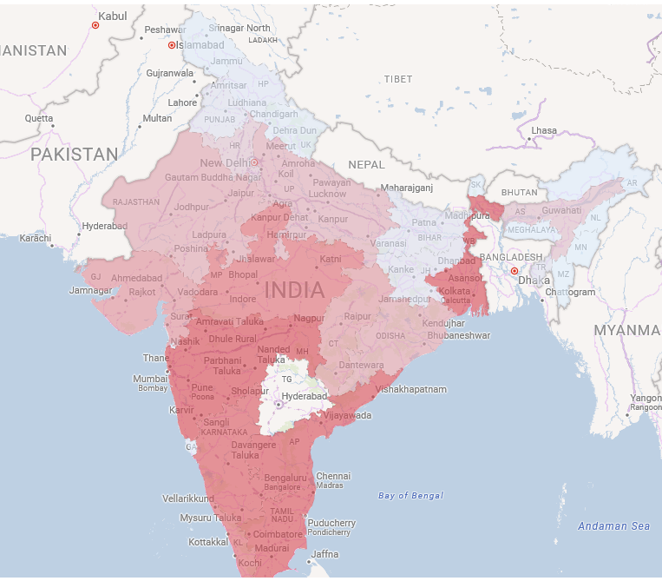

* + Power BI Interactive Heat map showing the clusters of high cases state wise. ( Above )

1. **Determining Factors:**
   * Explored factors such as family problems, mental illness contributing the most to suicide clusters for a comprehensive understanding.

**User Interface Development**

**Framework and Features**

1. **Framework:**
   * Developed a user-friendly interface using Power BI for seamless user interaction.

1. **Region-Based Helpline Numbers:**
   * Implemented a feature displaying Tollfree suicide helpline number.



1. **Interactive Maps and Graphs:**
   * Incorporated interactive maps and graphs to visualize suicide clusters and trends.

**Success Metrics**

1. **Suicide Cluster Identification:**
   * Successfully identified suicide clusters and their characteristics.
2. **User Interface Success:**
   * The user interface effectively provides access to suicide helpline numbers for different regions.

**Bonus Points Achieved**

1. **Suicide Cluster Identification:**
   * Successfully identified suicide clusters and their characteristics.
2. Higher income class has lesser suicidal rates.
3. Hanging is the emost common menas of suicide,
4. House wife have most suicidal case in professional classification.
5. Married people have more case of suicide.
6. Upward trend in year 2005 about 13% rise in cases in 7 Years A graph with a line going up

   Description automatically generated
7. Tamil Nadu, Gujarat, MP accounted for majority of increase offsetting the decrease of West Bengal

1. **User Interface Success:**
   * The user interface effectively provides access to suicide helpline numbers for different regions.

This report serves as an overview of the project, and the attached Power BI dashboard snapshots and an open link provide a detailed demonstration of the outcomes. Access the Power BI dashboard here.

https://app.powerbi.com/view?r=eyJrIjoiZGJkZGI2M2ItZWM0NC00Y2I5LTkyZDAtNGFmOTUwMjZjZGYzIiwidCI6ImZiNWIxYzllLTZlMDUtNDFkZS04ODNlLTdhZjUwYjA3Y2U2ZSIsImMiOjZ9&pageName=ReportSection

Submitted by

Devvrat